

**Robotics Project Tutorial**

**Team Members:**

1. **Md. Rakibul Islam** , ID: 0242310005341170
2. **Hridoy Hasan Mahim** , ID: 221-35-1051
3. **Emran Hossen Shuvo** , ID: 0242220005341082
4. **Fatir Bin Abdullah** , ID: 221-35-1085

**Course Teacher:**

**Md. Hafizul Imran**

**Senior Lecturer**, Department Of Software Engineering

**Lab In-Charge** of Daffodil Robotics Club

**Convenor**, DIU Robotics Club

**Submission Date :** 07/12/2024

**SMART PLANT MONITORING SYSTEM**

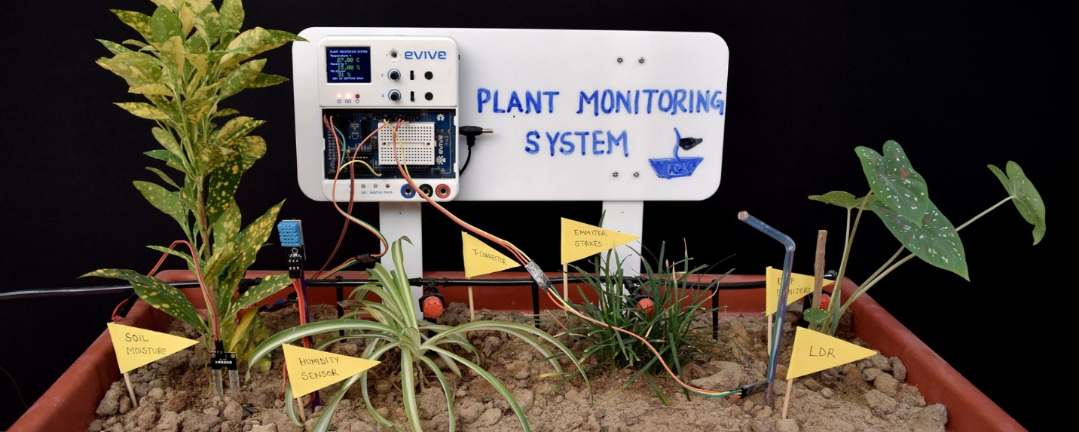

**Objectives:**

* Automatically check the soil’s moisture to know when plants need water.
* Measure the temperature and humidity around the plants to ensure a healthy environment.
* Save water by controlling the irrigation process based on soil needs.
* Reduce the time and effort needed for plant care with automation.
* Show real time information about plant conditions on a display.
* Help maintain plant health by giving accurate and timely updates.
* Make the system user-friendly and easy to use for everyone.

**Components Used:**

|  |  |  |
| --- | --- | --- |
| Component | Quantity | Description |
| LCD Display | 1 | For displaying system status |
| PIR Motion Sensor | 1 | To detect movement |
| Soil Moisture Sensor | 1 | For soil moisture detection |
| DHT 11 Sensor | 1 | For temperature and humidity |
| ESP8266 | 1 | Main Controller |
| Water Pump | 1 | For irrigation |
| Relay Module | 1 | To control the water pump |
| Breadboard | 1 | To connect components |
| Battery | 2 | To power the system |

**Overview:**

This tutorial will teach you how to create a smart plant monitoring system. The system uses sensors to check soil moisture, temperature, and humidity. It helps take care of plants by watering them only when needed. A water pump is controlled automatically based on the soil's dryness. The information about the plant’s environment is shown on an LCD screen, making it easy to understand. This system is useful for people who want to grow plants but don’t have enough time to check on them every day. It saves water and keeps plants healthy by providing the right amount of care. The tutorial is easy to follow, with step-by-step instructions, pictures, and code examples. By the end, you will have a fully working system that helps manage plant care more efficiently and conveniently.

**Let’s Start Building:**

ESP8266 Setup: Adjusting the ESP8266 on the breadboard to connect the components.

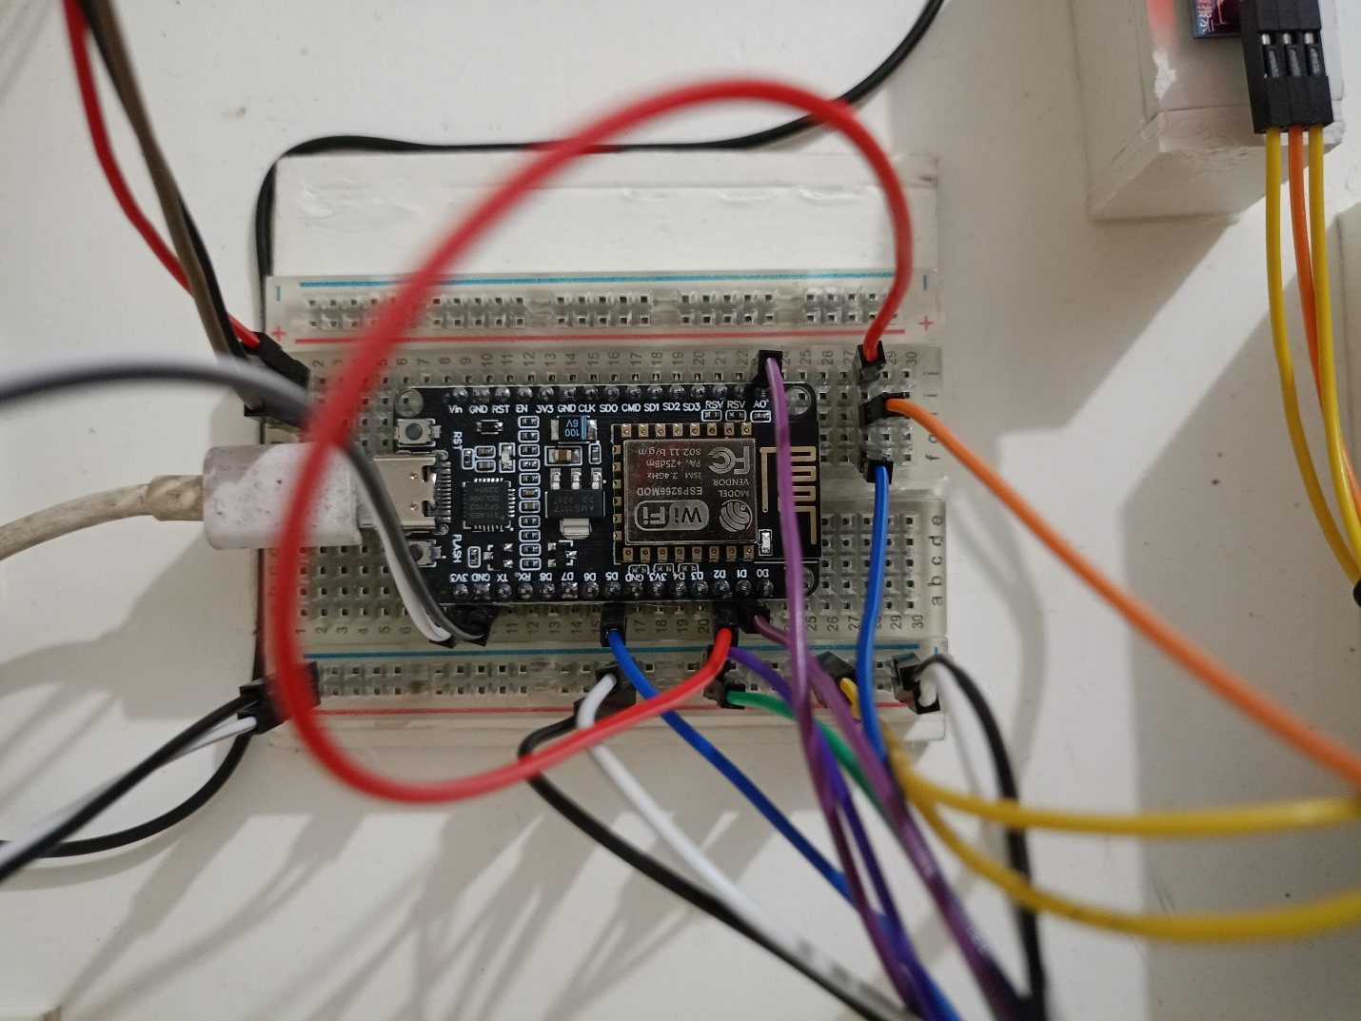

PIR Motion Sensor Setup: Connect the PIR Motion Sensor to the ESP on breadboard. It would detect the insect around the plant and show a message in the LCD screen.

PIN Connection: VCC – 3V, Output – D5, GND – GND.

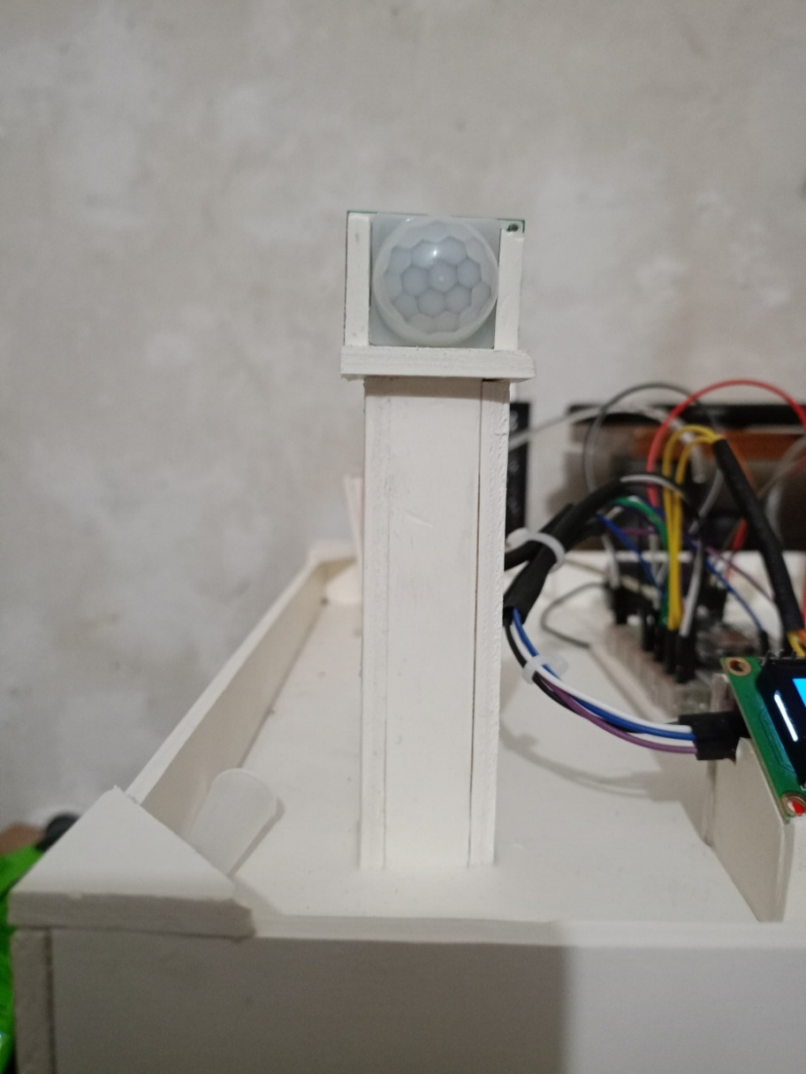

**PIR Sensor Code:**

void PIRsensor() {

delay(1500);

int motionSensor= D5;

currentTime = millis();

if (currentTime - previousMotionCheckTime >= motionCheckInterval) {

int isMotionDetected = digitalRead(motionSensor);

if (isMotionDetected == 0) {

Serial.println("Motion ended!");

lcd.print("No motion");

} else {

Serial.println("Motion detected!");

lcd.print("Motion");

}

previousMotionCheckTime = currentTime;

}

}

void loop() {

if (PIR_ToggleValue == 1) {

PIRsensor();

}

**DHT 11 Code:**

void DHT11sensor() {

delay(2000);

float tc = dht.readTemperature(false);

float tf = dht.readTemperature(true);

float hu = dht.readHumidity();

if (isnan(tc) || isnan(hu)) {

Serial.println("Failed to read from DHT sensor!");

lcd.setCursor(0, 0);

lcd.print("DHT Error!");

return;}

Serial.print("Temp: ");

Serial.print(tc);

Serial.print(" C, ");

Serial.print(tf);

Serial.print(" F, Hum: ");

Serial.print(hu);

Serial.println("%");

lcd.setCursor(0, 0);

lcd.print("T:");

lcd.print(tc);

lcd.print("C ");

lcd.setCursor(8, 0);

lcd.print("H:");

lcd.print(hu);

lcd.print("%");}

DHT11 Sensor Setup: DHT11 works to collect data on temperature and humidity and show the output in the display.

PIN Connection: VCC – 3V, GND – GND, DAT – D4.

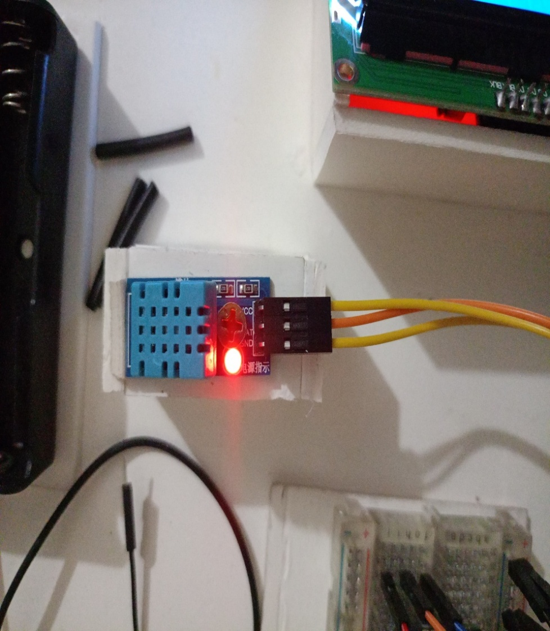

Soil Sensor Setup: Soil Moisture sensor collect data on moisture level in the soil and show the result in the display whether the is Normal or Wet or Dry.

**Soil Sensor Code:**

void soilMoistureSensor() {int sensorValue = analogRead(SENSOR_PIN); int moisturePercentage = map(sensorValue, 0, 1023, 0, 100); Serial.print("Raw Sensor Value: "); Serial.print(sensorValue); Serial.print(" | Moisture Percentage: ");Serial.print(moisturePercentage); Serial.print("% | ");if (moisturePercentage < 30) {

Serial.println("Soil is Dry");

//lcd.clear();

lcd.setCursor(5, 1);

lcd.print("Dry Soil");} else if (moisturePercentage < 70) { Serial.println("Soil is Normal"); //lcd.clear(); lcd.setCursor(5, 1); lcd.print("Wet Soil");

} else { Serial.println("Normal Soil"); lcd.setCursor(5, 1); lcd.print("Normal Soil"); }delay(1000); }

PIN Connection: VCC – 3V, GND – GND, A0 – A0.

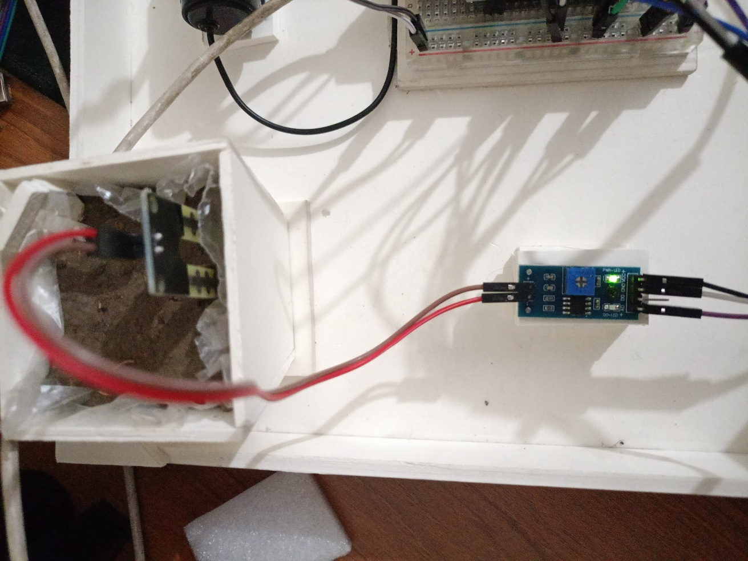

LCD Display Setup: This LCD Display setting would show the collected data from all three sensors.

**LCD Code:**

void setup() {

Serial.begin(9600);

Wire.begin();

lcd.begin(16, 2);

lcd.backlight();

pinMode(SENSOR_PIN, INPUT);

pinMode(PIR, INPUT);

pinMode(LED_BUILTIN, OUTPUT);

digitalWrite(LED_BUILTIN, HIGH);

dht.begin();

lcd.setCursor(0, 0);

lcd.print(" Initializing ");

for (int a = 5; a <= 10; a++) {

lcd.setCursor(a, 1);

lcd.print(".");

delay(500);}

lcd.clear();

lcd.setCursor(0, 1);

lcd.print("M:OFF");}

PIN Connection: GND – GND, VCC – 3V, SDA – D2, SCL – D1.

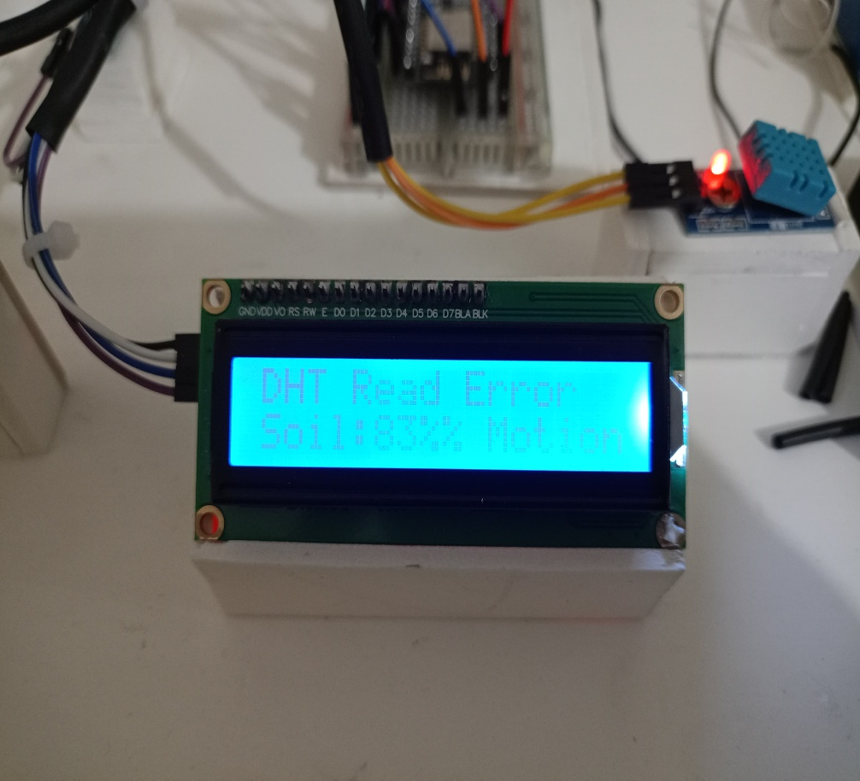

**Final Output Of The Project:**

https://drive.google.com/file/d/1FN8WRui2pidmxibUL07bAHfPa71G8kNc/view?usp=drive_link

**Conclusion:**

In this tutorial, we built a smart plant monitoring system that makes taking care of plants easy and efficient. The system checks the soil moisture and controls watering automatically, helping save water and keeping plants healthy. It also shows important information like temperature and humidity on an LCD screen. This project is useful for busy people who want to grow plants without spending too much time on care. By following this tutorial, you learned how to use sensors, a water pump, and coding to create an automated solution. This system is a step towards smarter and eco-friendly gardening.